**LEARNING OUTCOME**

Paste the picture of the Church where you belong.

Name: MAGBOJOS, JERVIN KIM A.

Your Address: GELERANG, KAWAYAN SAN PASCUAL, BATANGAS

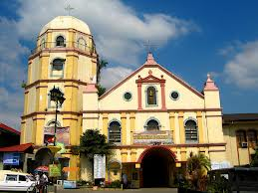

.

Name of the Parish: San Pascual Baylon, Church

Complete Address: Bauan - Batangas Provincial Rd, San Pascual, 4204 Batangas

Vicariate: Holy Cross

Name of the Parish Priest: Fr. Virgilio Ramos

Name of the Assistant Priest/s: John Patrick Gumasing